I am selling my 1957 T-Bird Convertible with 42,000 miles and wanted to put it out to this group since you all have a passion for these Classic cars.   This pink T-Bird is located in The Villages, FL and I would be happy to set up an appointment for anyone to see the vehicle in person or provide as many photo’s as you would like.  Please let me know if you or someone else has any interest in this Classic Car.

The asking price for this vehicle is $39,000 but we are willing to negotiate.

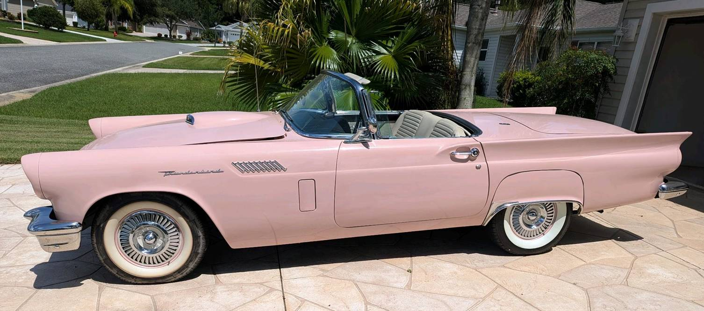

Thanks

|  |  |  |  |  |  |
| --- | --- | --- | --- | --- | --- |
| |  | | --- | | **Brett Crawford** | | President/CEO | |  |  | [A logo with text on it  Description automatically generated](https://na01.safelinks.protection.outlook.com/?url=http%3A%2F%2Ftroyinnovative.com%2F&data=05%7C02%7C%7C91eb8c69a2a24b6946de08dccc495d54%7C84df9e7fe9f640afb435aaaaaaaaaaaa%7C1%7C0%7C638609862865212967%7CUnknown%7CTWFpbGZsb3d8eyJWIjoiMC4wLjAwMDAiLCJQIjoiV2luMzIiLCJBTiI6Ik1haWwiLCJXVCI6Mn0%3D%7C0%7C%7C%7C&sdata=7BPWd8AuuawAGzs3lkXw00NIgmUvrVssQaQTsXwGi0w%3D&reserved=0) |
| phone (m) 440-313-8738 | 15111 White Rd. |
| phone (o) 440-834-9567 | Middlefield, Ohio 44062 |
| fax 440-834-8058 | [http://www.czacklaw.com/face.png](https://na01.safelinks.protection.outlook.com/?url=https%3A%2F%2Fwww.facebook.com%2Fpages%2FTroy-Innovative%2F103394213061322&data=05%7C02%7C%7C91eb8c69a2a24b6946de08dccc495d54%7C84df9e7fe9f640afb435aaaaaaaaaaaa%7C1%7C0%7C638609862865227022%7CUnknown%7CTWFpbGZsb3d8eyJWIjoiMC4wLjAwMDAiLCJQIjoiV2luMzIiLCJBTiI6Ik1haWwiLCJXVCI6Mn0%3D%7C0%7C%7C%7C&sdata=8Uz%2BobKG6%2Bfu4eIkxFZBVo0jsvgyf1SDo8jyBXVlIKk%3D&reserved=0)[http://www.czacklaw.com/LinkedIn.png](https://na01.safelinks.protection.outlook.com/?url=https%3A%2F%2Fwww.linkedin.com%2Fcompany%2Ftroy-innovative-instruments&data=05%7C02%7C%7C91eb8c69a2a24b6946de08dccc495d54%7C84df9e7fe9f640afb435aaaaaaaaaaaa%7C1%7C0%7C638609862865231762%7CUnknown%7CTWFpbGZsb3d8eyJWIjoiMC4wLjAwMDAiLCJQIjoiV2luMzIiLCJBTiI6Ik1haWwiLCJXVCI6Mn0%3D%7C0%7C%7C%7C&sdata=RGNp0VGX5AOgCPO1uv5XcZPmPTPXxMB8WdqYVSGAQKg%3D&reserved=0) |
| [bcrawford@troyinnovative.com](mailto:bcrawford@troyinnovative.com) | [www.troyinnovative.com](https://na01.safelinks.protection.outlook.com/?url=http%3A%2F%2Fwww.troyinnovative.com%2F&data=05%7C02%7C%7C91eb8c69a2a24b6946de08dccc495d54%7C84df9e7fe9f640afb435aaaaaaaaaaaa%7C1%7C0%7C638609862865236239%7CUnknown%7CTWFpbGZsb3d8eyJWIjoiMC4wLjAwMDAiLCJQIjoiV2luMzIiLCJBTiI6Ik1haWwiLCJXVCI6Mn0%3D%7C0%7C%7C%7C&sdata=OBaiCwZDZMikQAr%2B7nXYpfYtrNi9QhN81MzyWubx3UI%3D&reserved=0) |