**FOR SALE – 1957 Thunderbird Restomod**

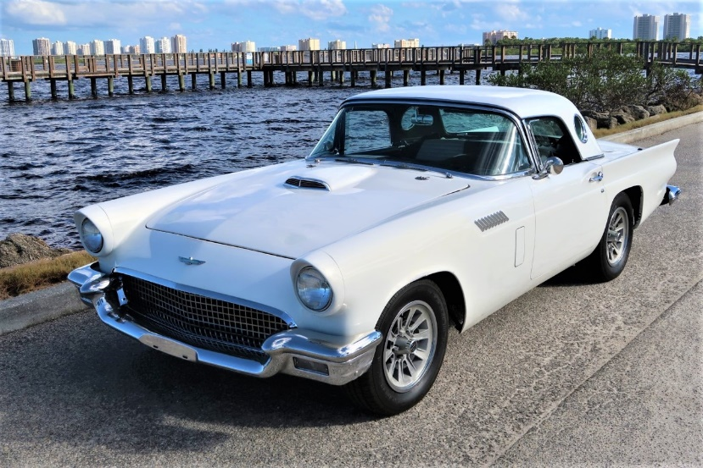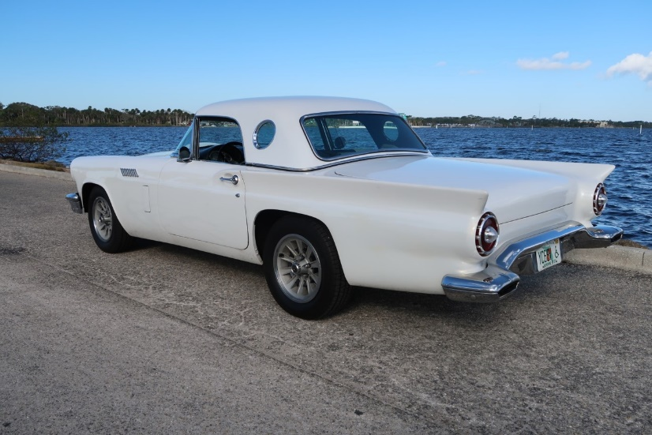

Ford 351 Windsor engine, Ford Automatic Overdrive transmission, Mustang Disc brakes, Ford 9 inch axle with 3.70 gears, new tires and new exhaust. 1978 Thunderbird 15” wheels with 215/65X15 Radial T/A tires, 1965 Thunderbird bucket seats, 1962 Falcon console. Has A/C that is not presently hooked up. Very solid car with no rust. Color is White Pearl with ghosted silver flames on the hardtop and doors. Edgewater, Florida **$25,000** Jeff Burgy [cobrajeff@att.net](mailto:cobrajeff@att.net)

**FOR Sale - 1957 Thunderbird Jr project**

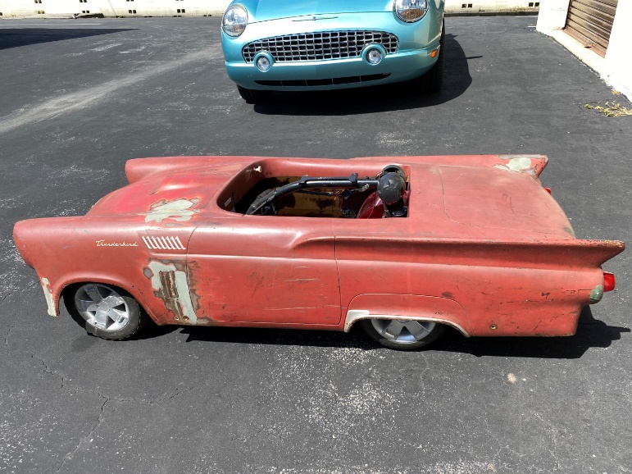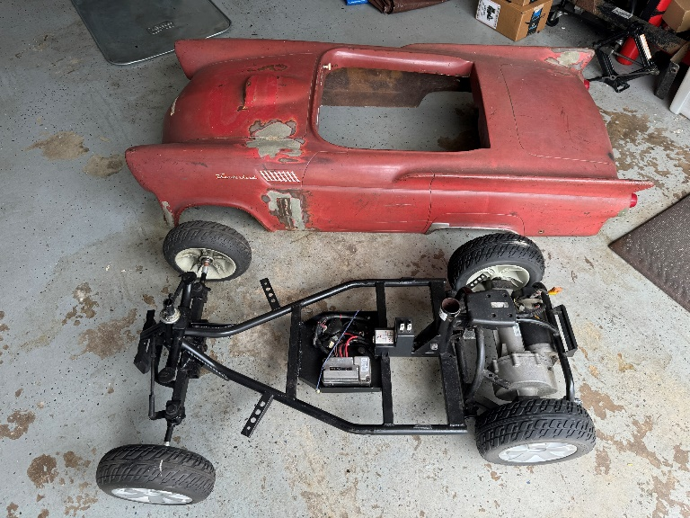

Chassis is a Pride Victory 10 Mobility scooter shortened to fit the T’Bird wheelbase. Brand new bumpers grille, steering wheel, wheel covers and taillights included. **$1,100** Jeff Burgy [cobrajeff@att.net](mailto:cobrajeff@att.net)